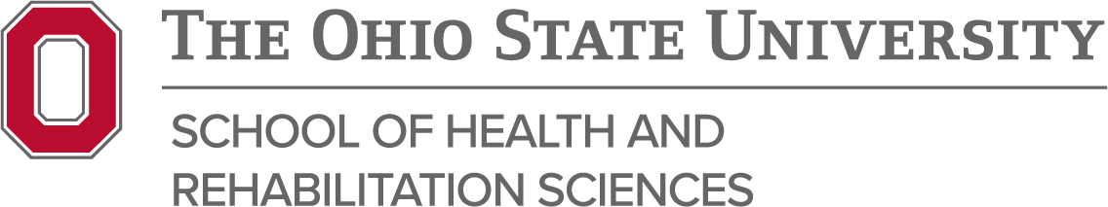

Radiography Program Student Learning Outcomes

Our mission is realized by assuring our students will be able to:

- Demonstrate critical thinking through evidence-based practice and professional decision making in the care of patients.

Learning Outcomes:
- Students will maintain clinical competency of examinations and apply critical thinking skills to adapt to non-routine patients and environments of patients.
- Students will critique radiographic images for diagnostic quality and recognize suboptimal images while providing corrective action to resolve these issues.

- Demonstrate clinical competency through mastery of knowledge, psychomotor skills and clinical reasoning while providing high quality patient care.

Learning Outcomes:
- Students will demonstrate mastery radiographic positioning skills.
- Students will demonstrate radiation protection principles to all patients, self, and others.
- Students will demonstrate quality patient care skills.
- Graduates will demonstrate competence in the work environment.

- Communicate in a clear and effective manner, both verbally and in writing with people of diverse backgrounds.

Learning Outcomes:
- Students will demonstrate effective oral communication with patients and staff.
- Students will demonstrate effective scientific writing and presentation skills.

- Cultivate a professional work ethic and interprofessional collaboration, demonstrating a positive attitude and leadership skills.

Learning Outcomes:
- Students/Graduates will exhibit a professional work ethic in the clinical setting.
- Students/Graduates will participate in interprofessional education (IPE) events throughout their time within the program.

*Updated 3/2026

