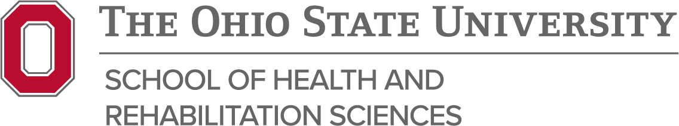

Radiation Therapy Program Student Learning Outcomes

Our mission is realized by assuring our students will be able to:
- Demonstrate critical thinking through evidence-based practice and professional decision making in the care of patients.
Learning Outcomes:
- Students will recognize and resolve deviations related to treatment delivery.
- Students will critique IGRT images when accurately defining the treatment fields.

- Demonstrate clinical competency through mastery of knowledge, psychomotor skills and clinical reasoning while providing high quality patient care.
Learning Outcomes:
- Students will demonstrate simulation skills.
- Students will demonstrate treatment delivery skills.
- Graduates will demonstrate competence in the work environment.

- Communicate in a clear and effective manner, both verbally and in writing with people of diverse backgrounds.
Learning Outcomes:
- Students will demonstrate effective oral communication.
- Students will demonstrate effective written communication.
- Students will demonstrate effective presentation skills.

- Cultivate a professional work ethic, demonstrating a positive attitude and leadership skills. Learning Outcome:
- Students/Graduates will exhibit a professional work ethic in the clinical setting.

*Updated 3/2026

